

**Computer Vision Project Group - 7**

**Week-4: Progress Report**

**Project Title:**

**American Sign Language Alphabet Detection**

**Submitted to faculty: Prof. Mehul Raval**

**Group Members:**

| **JILL SHAH** | **AU2040234** |
| --- | --- |
| **KHUSHEE VAKIL** | **AU2040242** |
| **DHRUVI SHAH** | **AU2040263** |

**Tasks performed this week:**

1. For our project, we have chosen to employ the ResNet152 model. Microsoft Research Asia originally unveiled ResNet-152, a deep convolutional neural network (CNN) architecture with 152 layers, in 2015.
2. Skip connections are used in the ResNet-152 design to get around the issue of vanishing gradients and enhance the network's capacity for learning and generalization. The issue of vanishing gradients is helped by the skip connections, which allow the gradient to pass directly across the network.
3. On a variety of computer vision tasks, including image classification, object detection, and semantic segmentation, ResNet-152 has demonstrated state-of-the-art performance. It has been applied to a variety of tasks, including natural language processing, autonomous driving, and facial recognition.
4. The use of ResNet-152 in object recognition is one instance. ResNet-152 can recognize and categorize objects within an image by detecting features in the image, which is beneficial in a variety of industries like security and surveillance, retail, and autonomous vehicles. Another instance is in the classification of various diseases or conditions in medical images using ResNet-152, such as recognising tumours in MRI scans.

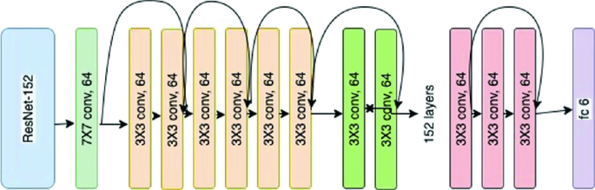

Overall, ResNet-152 is a powerful and versatile neural network architecture that can be used in a wide range of computer vision applications.